Credit Card Fraud Detection

ITRI 623 Project

34687602

Charmain Lebelo

# Brief Description of the system

The Real-time fraud detection of the system is a sophisticated architecture designed to meticulously monitor, identify, and flag potentially fraudulent activities in credit card transactions. It employs a blend of python and Azure services to facilitate a seamless flow and analysis of transactional data in real-time. The system is engineered for immediate ingestion of transactional data, robust stream processing, secure and organized data storage, and compelling data visualization and analysis, ensuring a comprehensive approach to fraud detection.

The data journey commences with a tailored Python script that orchestrates the careful ingestion of transactional data into the Azure Event Hub. Acting as a pipeline, the Event Hub seamlessly transmit the ingested data into the Azure Stream Analytics. Here, in the realm of the real-time processing, the data undergoes meticulous scrutiny, filtered, and analysed according to predefined parameters to identify potentially fraudulent activities. Following this analytical process, the curated data finds its repository in Azure Cosmos DB, where it is securely housed and made readily available for further exploration and analysis. Power BI assumes the final stage of this data flow, tapping into the Cosmos DB to harvest, visualize, and present the data, unfolding comprehensive insights into transactional patterns and suspected fraudulent activities. This thoughtful orchestration of data flow epitomizes a harmonized integration of technologies to unlock actionable insights from real-time transaction data.

# System Design (UML)

Endpoints

**Azure Event Hub**: A pivotal component that ingests and disseminates real-time transaction data, acting as a unified streaming platform.

**Azure Cosmos DB**: Where processed and analysed data is securely stored, enabling structured organization and efficient retrieval for further analysis and visualization.

Design Patterns

**Publisher-Subscriber Pattern:** Utilized within the Azure Event Hub, allowing various system components to seamlessly subscribe to real-time data streams.

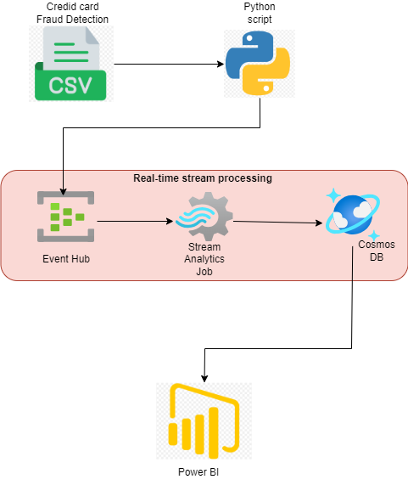

Figure : Credit card fraud detection system design

# Tools/services used.

1. Azure Event hub: Facilitates the immediate ingestion of transactional data, acting as the initial point of data entry into the system.
2. Azure Stream Analytics: Employs real-time analytics and complex event processing, applying specific rules and queries to identify potential fraudulent transactions.
3. Azure Cosmos DB: A NoSQL database service that stores processes transactional data, ensuring data is readily available for querying and analysis.
4. Power BI: A business analytics tool utilized for the visualization of the processed data, facilitating a comprehensive exploration and interpretation of transactional patterns and suspected fraudulent activities.

# Conclusion

The real-time fraud detection system exemplifies a robust, real-time processing architecture that seamlessly integrates various Azure service together with a python script to deliver a comprehensive solution for identifying and flagging fraudulent activities within credit card transactions, ensuring enhanced security and reliability.